

Darshan University

A Project Report on

**“Blood Bank Management System”**

Under the subject

**Software Engineering (2301CS405)**

B. Tech, Semester – IV

Computer Science & Engineering Department

|  |  |
| --- | --- |
| Submitted By | |
| Student Name: Odedra Viraj Arjanbhai | Enrollment No.:23010101178 |
| Academic Year  (2024-2025) | |
| Internal Guide  Prof. R. B. Gondaliya  Darshan University | Dean-DIET  Dr. Gopi Sanghani  Darshan University |

|  |  |
| --- | --- |
|  | **Computer Science & Engineering Department**  **Darshan University** |

**DECLARATION**

We hereby declare that the SRS, submitted along with the **Software Engineering** **(2301CS405)** for entitled **“Blood Bank Management System”** submitted in partial fulfilment for the Semester-5 of **Bachelor Technology (B. Tech)** in **Computer Science and Engineering (CSE)** Departmentto Darshan University, Rajkot, is a record of the work carried out at **Darshan University, Rajkot** under the supervision of R. B. Gondaliya and that no part of any of report has been directly copied from any students’ reports, without providing due reference.

(Odedra Viraj Arjanbhai)

Student’s Signature

Date: __________

|  |  |
| --- | --- |
|  | **Computer Science & Engineering Department**  **Darshan University** |

**CERTIFICATE**

This is to certify that the SRS on **“Blood Bank Management System” has** been satisfactorily prepared by **Odedra Viraj Arjanbhai**(23010101178) under my guidance in the fulfillment of the course **Software Engineering (2301CS405)** work during the academic year 2024-2025.

|  |  |  |
| --- | --- | --- |
| Internal Guide  Prof. R. B. Gondaliya  Darshan University |  | Dean-DIET  Dr. Gopi Sanghani  Darshan University |

**Acknowledgement**

I wish to express my sincere gratitude to my project guide Prof. R. B. Gondaliyaand all the faculty members for helping me through my project by giving me the necessary suggestions and advices along with their valuable co- ordination in completing this work.

I also thank my parents, friends and all the members of the family for their precious support and encouragement which they had provided in completion of my work. In addition to that, I would also like to mention the Darshan University personals who gave me the permission to use and experience the valuable resources required for the project from the University premises.

Thus, in conclusion to the above said, I once again thank the faculties and members of **Darshan University** for their valuable support in completion of the project.

Thanking You

**Odedra Viraj Arjanbhai**

**ABSTRACT**

Blood Bank Management System is a system which aims in developing a computerized system to maintain all the daily work of a blood bank. This system will act as a tool to transfer the traditional blood bank operations into a digital platform. This project has many features which are generally not available in general blood bank systems, such as the facility of user login, blood search, and donation tracking with a single click. It also has a facility of admin login through which the admin can monitor the whole system. This system will be designed with the basic features such as the admin can add/view/update/delete blood donor and recipient details. It also provides a feature where donors, after logging into their accounts, can see a list of their past donations, donation dates, and certificates. Recipients, after logging into their accounts, can request blood, track the status of their requests, and view available blood types. The admin, after logging into their account, can generate various reports such as donation reports, recipient requests, and blood stock reports.

Main purpose of this system is to reduce human efforts as much as possible.

**Table of Contents**

List of Figures I

List of Tables II

1 Introduction 1

1.1 Product perspective 1

1.2 Product features 1

1.2.1 There are four different users who will be using this product: 1

1.2.2 The features required for the Admin are: 1

1.2.3 The features that are required for Donor are: 1

1.2.4 The features required for the Recipient are: 1

1.2.5 The features required for the Hospital are: 1

1.3 Functional Requirement 2

1.3.1 Blood Donor 2

1.3.2 Recipient 2

1.3.3 Hospital 2

1.3.4 Admin 2

1.4 Non-Functional Requirement 3

1.4.1 Usability: 3

1.4.2 Accuracy: 3

1.4.3 Availability: 3

1.4.4 Maintainability: 3

2 Design and Implementation Constraints 4

2.1 Use case diagram 4

2.2 Activity diagram and Swimlane diagram 5

2.3 Sequence diagram 7

2.4 State diagram 8

2.5 Class diagram 9

2.6 Data flow diagram 10

2.6.1 Context diagram (level-0) 10

2.6.2 DFD Level-1 11

2.6.3 DFD Level-2 12

3 External interface requirement (Screens) 13

3.1 Screen-1: Blood Stock Availability 13

3.2 Screen-2: Thalassemia Request 14

3.3 Screen-3: Blood Storage Unit 16

3.4 Screen-4: Blood Camp Schedule 17

3.5 Screen-5: Camp Registration 18

4 Database design 20

4.1 List of Tables 20

5 Stories and Scenario 22

5.1 Story-1: Add New Book in Library Catalogue 22

5.1.1 Scenario# S1.1 22

5.1.2 Scenario# S1.2 22

5.1.3 Scenario# S1.3 22

5.2 Story-2: Search Book 23

5.3 Story-3: Manage due date for borrowed book 23

5.4 Story-4: Renew book 23

5.5 Story-5: Generate a report on book usage and availability 23

6 Test cases 24

7 References 28

# List of Figures

Figure 2.1 Use case diagram for Blood Bank management system 4

Figure 2.2 Activity Diagram for Blood Donor 5

Figure 2.3 Activity Diagram for Blood Recipient 5

Figure 2.4 Swimlane Diagram For Blood Recipient 6

Figure 2.5 Swimlane Diagram For Blood Donor 6

Figure 2.6 Sequence Diagram For Blood Donor 7

Figure 2.7Sequence Diagram for Blood Recipient 7

Figure 2.8 State Diagram For Blood 8

Figure 2.9 State Diagram for Blood Request 8

Figure 2.10 Class diagram for Blood Bank Management System 9

Figure 2.11 Context diagram for Blood Bank Management System 10

Figure 2.12 DFD level-1 for Blood Bank Management System 11

Figure 2.13 DFD level-2 for Issue book 12

Figure 3.1 Screen-1: Blood Stock Availability 13

Figure 3.2 Screen-2: Thalassemia Request 14

Figure 3.3 Screen-3: Blood Storage Unit 16

Figure 3.4 Screen-4: Search Donor Availability 17

Figure 3.5 screen-5 Blood Camp Registration 18

Figure 3.6-1 Screen-5: Schedule an appointment 19

# List of Tables

Table 3.1‑1 Screen element of Blood Stock Availability 13

Table 3.2‑1 Screen element of Thalassemia Request 14

Table 3.3‑1 Screen element of Blood Storage Unit 16

Table 4.1‑1 Table: Book 20

Table 4.1‑2 Table: Borrower 21

Table 4.1‑3 Table: Staff 21

Table 4.1‑4 Table: Student 21

# Introduction

## Product perspective

This project aims to update the traditional blood bank management system into an internet-based application, allowing users to easily access information about blood availability, donation status, and their account details. It is a multi-user system that efficiently handles essential functions of a blood bank, including blood donation, inventory management, recipient requests, and emergency handling. The system is designed to support all the basic operations of a blood bank, ensuring smooth management of blood donations, tracking blood stock, and improving communication between donors, recipients, and hospitals. It can effectively cater to the needs of a small to medium-sized blood bank.

## Product features

### There are four different users who will be using this product:

* Admin (Blood Bank Manager): Oversees all operations of the blood bank.
* Donor: Donates blood to the bank.
* Recipient: Requests blood based on medical needs.
* Hospital: Receives blood for patients who need it.

### The features required for the Admin are:

* Generate Reports: Create reports on blood donations, requests, and inventory status.
* Track Donor and Recipient Data: View history of donors and track blood requests from recipients.
* Approve Donors: Check if donors have the health requirements and approve them.
* Blood Requests: Monitor and restock blood requests from hospitals or recipients.
* Emergency Blood Requests: Handle urgent blood requests during emergencies.
* Issue Blood Units: Give blood to hospitals or recipients as needed.

### The features that are required for Donor are:

* Donate Blood: Donate blood if eligible and available at donation camps or blood banks.
* View Donation History: See a list of past donations and details of each donation.
* Create an Account: Create and check a profile to track donations and receive certificates.
* Request Donation Certificates: Get certificates as proof of blood donation.
* Track Donation Camps: View upcoming blood donation drives or events.

### The features required for the Recipient are:

* Request Blood: Request blood if needed for medical treatment.
* View Request History: See the list of past blood requests and their statuses.
* Create an Account: Create a profile for blood requests and track status.
* Receive Notifications: Get updates on blood availability and request status.
* Search Available Blood: Find available blood types in nearby blood banks.

### The features required for the Hospital are:

* Request Blood: Hospitals can request specific blood types for their patients.
* View Blood Usage History: See a list of blood units used by patients in the hospital.
* Check Blood Stock: Track and Check the blood received from the blood bank.

## Functional Requirement

### Blood Donor

* Registration: For registration donor needs to create an account that contains personal details.
* Eligibility: Verifies if the donor meets health and age criteria for donation.
* Donation History: Displays past donations, including dates and donation centers.
* Certificates: Provides downloadable certificates as proof of donation.
* Appointment: Enables donors to schedule or reschedule donation appointments.
* Update Profile: Allows updating personal information, contact details, and preferences.
* Event Donation: Facilitates participation in special donation drives or events.
* Feedback: Collects donor feedback to improve donation processes.
* Donation Analytics: Provides insights on the donor’s impact, such as the number of lives saved.

### Recipient

* Recipient Registration: Enables individuals to register as recipients by providing their personal and medical details.
* Search Blood Center: Allows recipients to locate nearby blood centers based on their location or specific blood type availability.
* Request Blood: Facilitates the submission of blood requests, including urgent requirements for specific blood groups.
* Check Status: Provides updates on blood request approvals, availability, and estimated delivery times.
* Check Donor History: Displays information about donors who have contributed.
* Give Feedback: Allows recipients to share their experiences with the blood center or donation process to enhance services.
* Track Delivery: Enables real-time tracking of blood units in transit to the recipient's location.
* Health Tips: Provides guidelines for recipients on post-transfusion care and maintaining health.

### Hospital

* Schedule Appointments: Schedule donor appointments for hospital blood.
* Verify Donor Eligibility: Check donor health details to ensure safe blood donations at the hospital.
* View Blood Storage: Enables hospitals to monitor available blood units by type and quantity in their storage.
* Check Feedback: Allows hospitals to review feedback from donors and recipients to improve services.
* Request Blood Stock: Submit requests for restock blood supplies based on current inventory levels.
* Resolve Complains: Hospitals can respond to complaints or queries from donor or recipients.

### Admin

* Access Privileges: Admins can control and assign access levels to different users (donors, recipients, hospitals) based on their roles.
* Check User Accounts: Admin can add, remove, or update user profiles to maintain a smooth workflow in the system.
* Respond to Complaints: Admin handles and resolves complaints or issues raised by users related to blood donation or blood bank services.
* Monitor Requests: Admin can track all blood requests made by recipients or hospitals and ensure timely they gate their needs.
* Generate Reports: Admin generates detailed reports on blood donations, stock levels, usage trends, and overall system performance.

## Non-Functional Requirement

### Usability:

* The UI should be simple enough for everyone to understand and get the relevant information without any special training. Different languages can be provided based on the requirements.

### Accuracy:

* The data stored about the books and the fines calculated should be correct, consistent, and reliable.

### Availability:

* The System should be available for the duration when the library operates and must be recovered within an hour or less if it fails. The system should respond to the requests within two seconds or less.

### Maintainability:

* The software should be easily maintainable and adding new features and making changes to the software must be as simple as possible. In addition to this, the software must also be portable.

# Design and Implementation Constraints

## Use case diagram

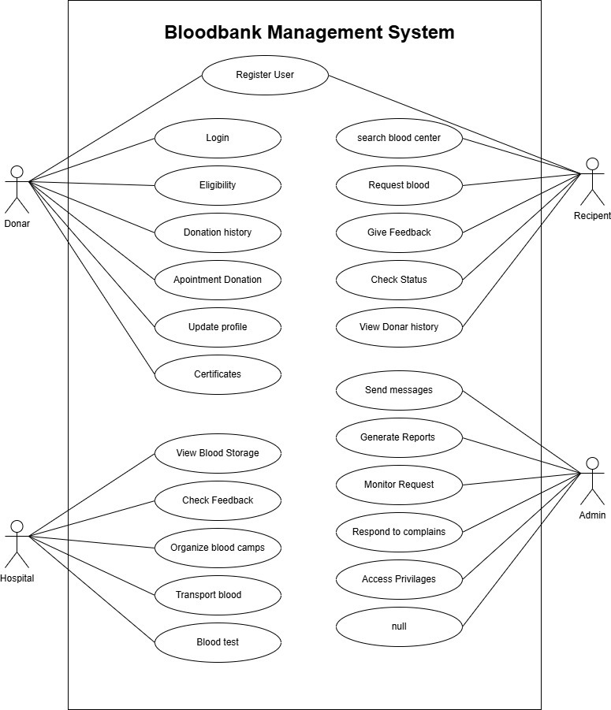

Figure 2.1 Use case diagram for Blood Bank management system

## Activity diagram and Swimlane diagram

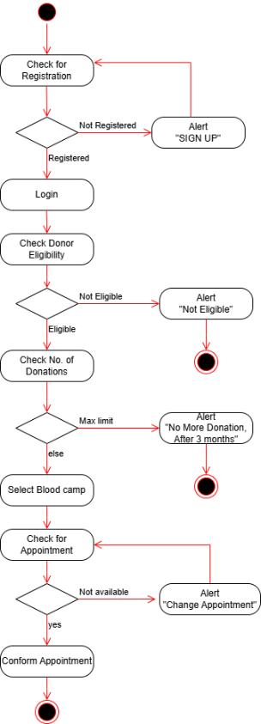

Figure 2.2 Activity Diagram for Blood Donor

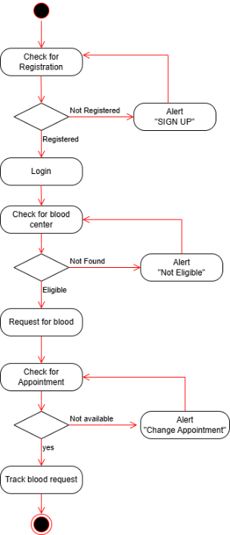

Figure 2.3 Activity Diagram for Blood Recipient

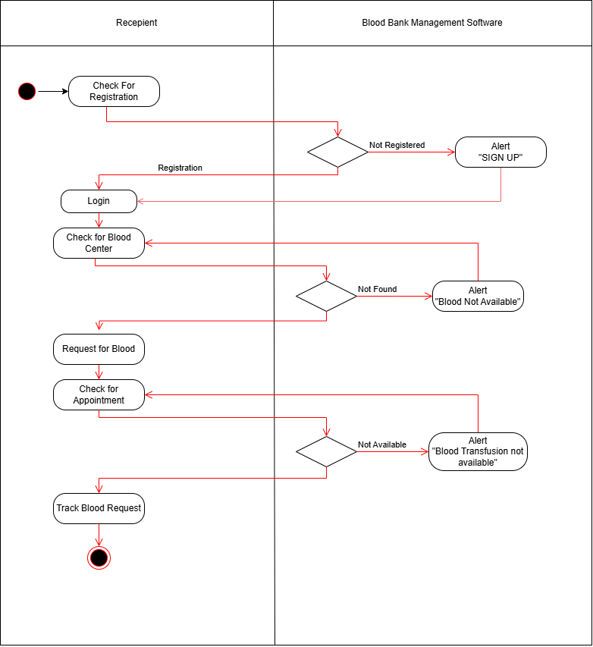

Figure 2.4 Swimlane Diagram For Blood Recipient

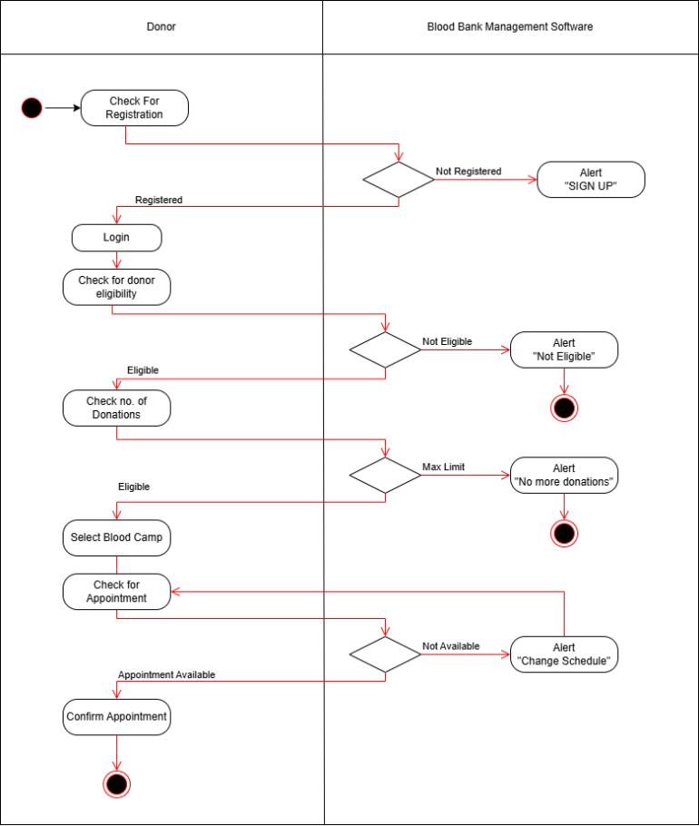

Figure 2.5 Swimlane Diagram For Blood Donor

## Sequence diagram

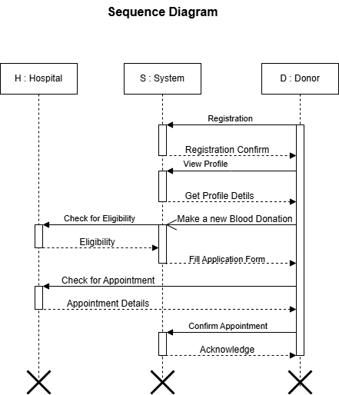

Figure 2.6 Sequence Diagram For Blood Donor

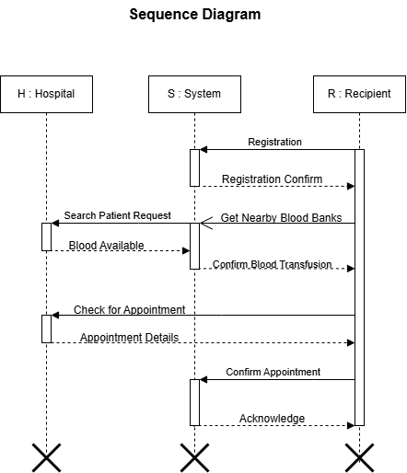

Figure 2.7Sequence Diagram for Blood Recipient

## State diagram

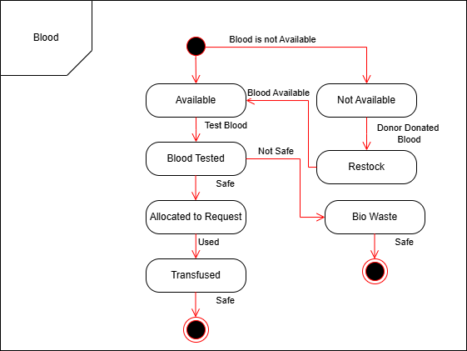

Figure 2.8 State Diagram For Blood

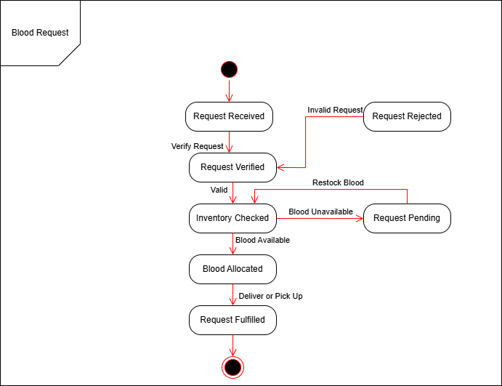

Figure 2.9 State Diagram for Blood Request

## Class diagram

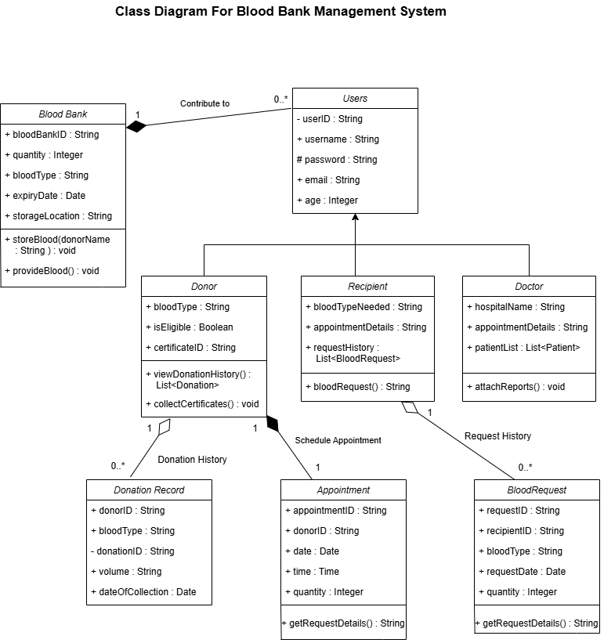

Figure 2.10 Class diagram for Blood Bank Management System

## Data flow diagram

### Context diagram (level-0)

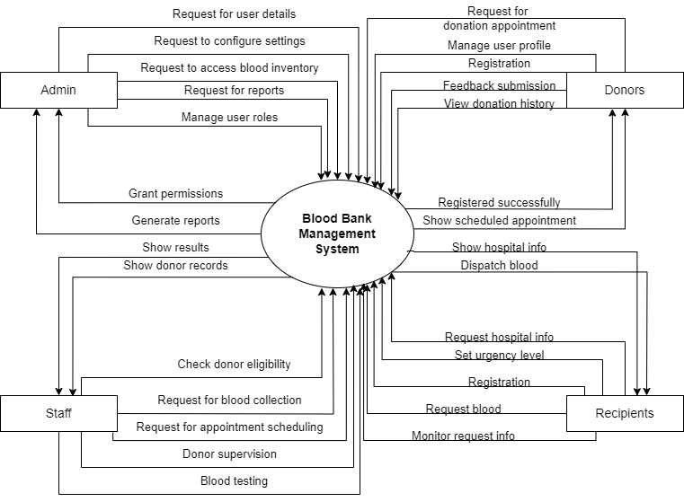

Figure 2.11 Context diagram for Blood Bank Management System

### DFD Level-1

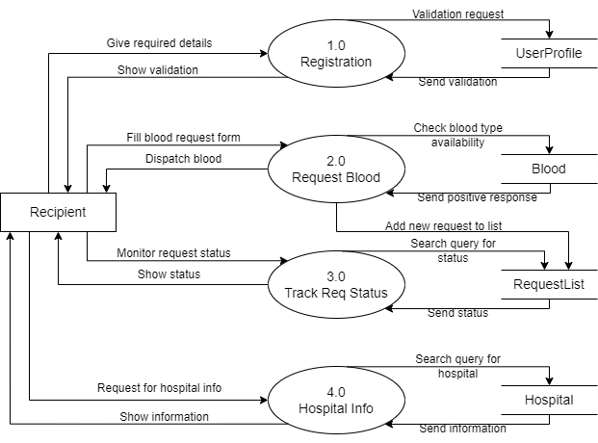

Figure 2.12 DFD level-1 for Blood Bank Management System

### DFD Level-2

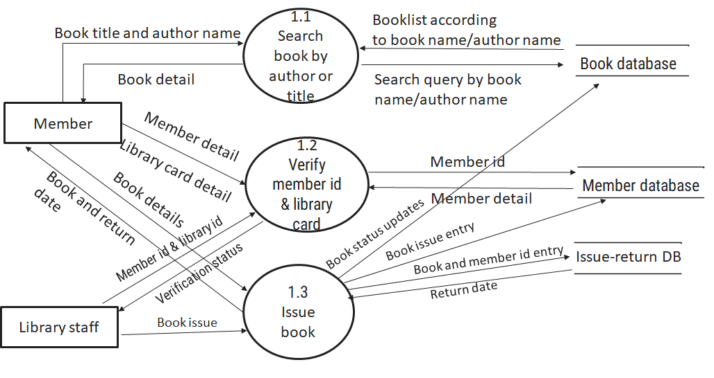

Figure 2.13 DFD level-2 for Issue book

# External interface requirement (Screens)

## Screen-1: Blood Stock Availability

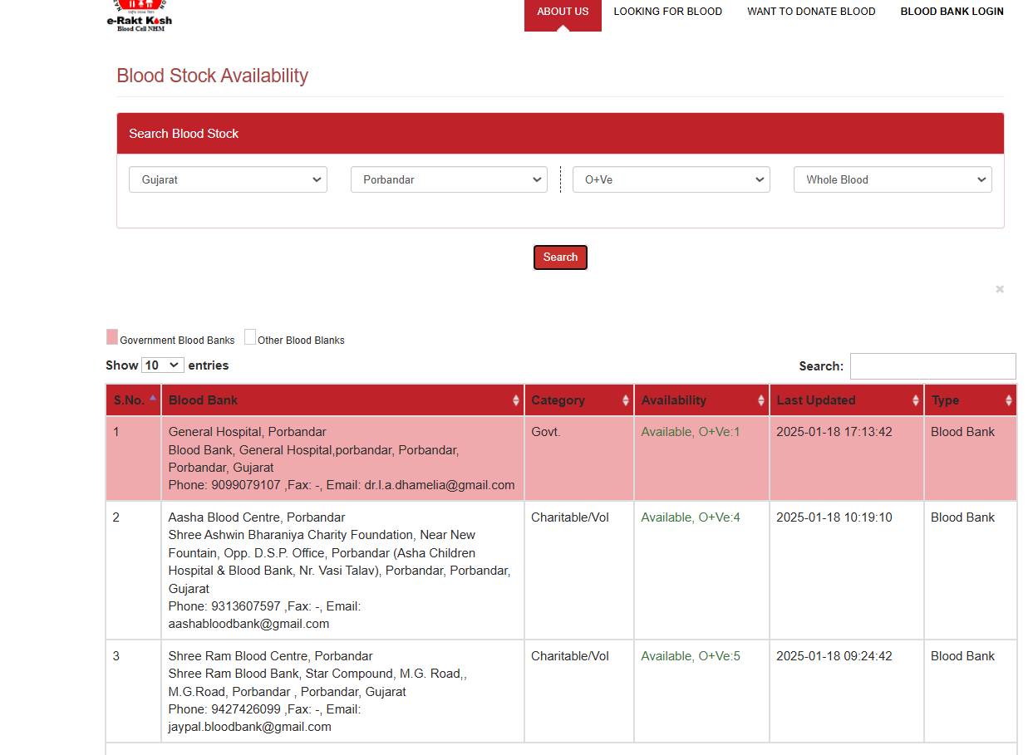

Figure 3.1 Screen-1: Blood Stock Availability

**Purpose:** T This form will allow the target end-users to check the availability of blood type in the system. To check the availability, the following information will be encoded in the system.

Table 3.1‑1 Screen element of Blood Stock Availability

|  |  |  |  |  |  |
| --- | --- | --- | --- | --- | --- |
| Sr. | Screen Element | Input Type | O/M | 1/N | Description |
| 1 | State | Select | M | 1 | Select state for a blood bank in which you are looking for blood stock availability. |
| 2 | City | Select | M | 1 | Select city for a blood bank in which you are looking for blood stock availability. |
| 3 | Blood Group | Select | M | 1 | Select blood group for which you are looking for stock availability. |
| 4 | Blood  Component | Select | M | 1 | Select blood component for which you are  looking for stock availability. |
| 5 | Search | Button | M | 1 | Click on the search button to view the desired search result. |
| 6 | Search Result | Table | M | 1 | Search result table indicates blood bank details from desired inputs. |
| 7 | Title | Text | M | 1 | A title describes what a given screen or interface is about. |

## Screen-2: Donor Feedback Form

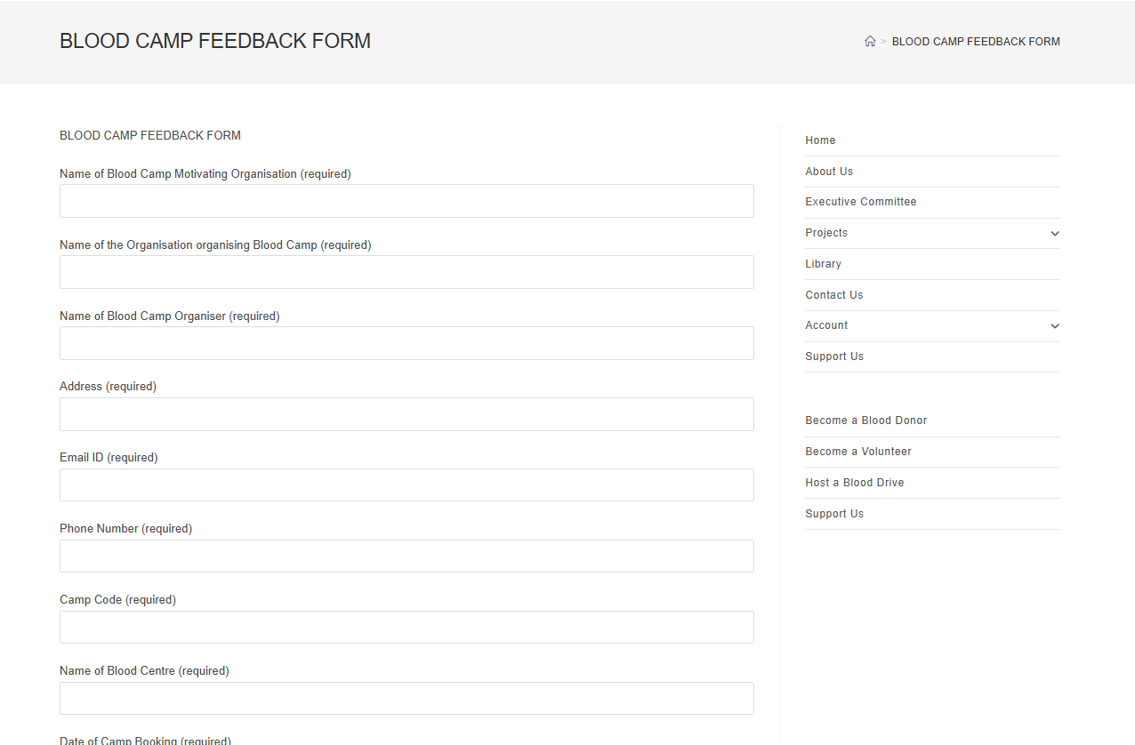

Figure 3.2 Screen-2: Blood Donor Feedback Form

**Purpose:** This screen serves as a Blood Camp Feedback Form that enables users to provide feedback regarding blood camps, specifically for activities such as blood donation camps. It also collects essential information about organizations and individuals responsible for organizing these camps to improve service delivery and ensure better management.

Table 3.2‑1 Screen element of Blood Donor Feedback Form

|  |  |  |  |  |  |
| --- | --- | --- | --- | --- | --- |
| Sr. | Screen Element | Input Type | O/M | 1/N | Description |
| 1 | Name of Blood Camp Motivating Organisation | Text Field | M | 1 | Allows users to input the name of the motivating organization for the blood camp. |
| 2 | Name of the Organisation organising Blood Camp | Text Field | M | 1 | Allows users to input the name of the organization responsible for organizing the camp. |
| 3 | Name of Blood Camp Organiser | Text Field | M | 1 | Allows users to input the name of the individual organizing the camp. |
| 4 | Address | Text Field | M | 1 | Allows users to input the address related to the camp. |
| 5 | Email ID | Text Field | M | 1 | Allows users to input the email ID for communication purposes. |
| 6 | Phone Number | Text Field | M | 1 | Allows users to input the phone number for contact purposes. |
| 7 | Camp Code | Text Field | M | 1 | Allows users to input a unique code identifying the camp. |
| 8 | Name of Blood Centre | Text Field | M | 1 | Allows users to input the name of the blood center associated with the camp. |
| 9 | Date of Camp Booking | Date Picker/Calendar | M | 1 | Allows users to select the date on which the camp booking is made. |

## Screen-3: Blood Storage Unit

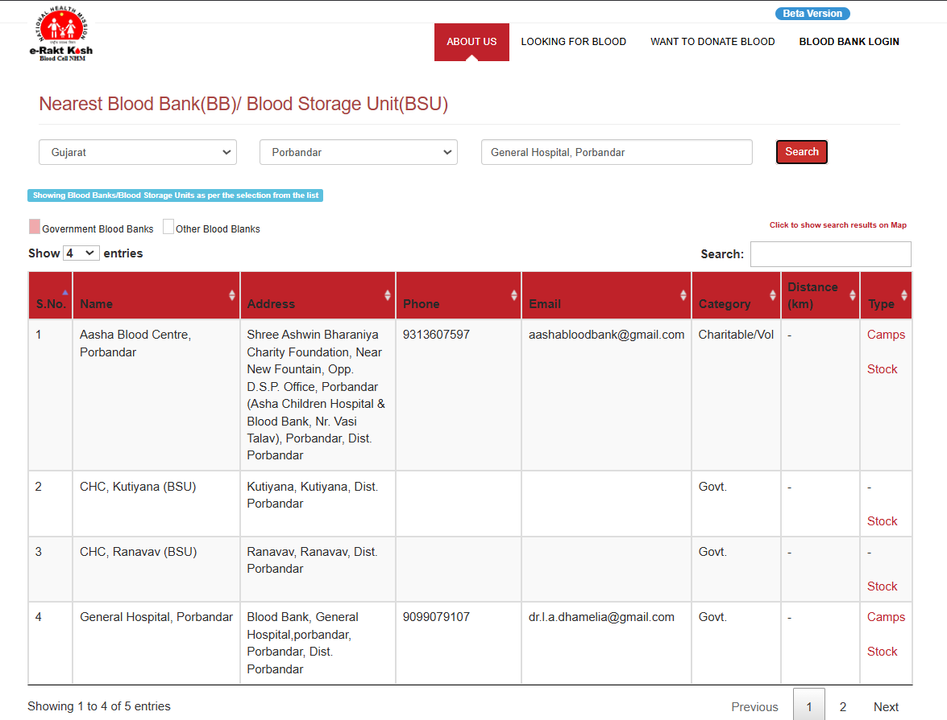

Figure 3.3 Screen-3: Blood Storage Unit

**Purpose:** This form will allow the target end-users to view blood storage unit of nearest blood banks in the system. To view the storage units, the following information will be encoded in the system.

Table 3.3‑1 Screen element of Blood Storage Unit

|  |  |  |  |  |  |
| --- | --- | --- | --- | --- | --- |
| Sr. | Screen Element | Input Type | O/M | 1/N | Description |
| 1 | State | Select | M | 1 | Select state for a blood bank in which you are looking for blood stock availability. |
| 2 | City | Select | M | 1 | Select city for a blood bank in which you are looking for blood stock availability. |
| 3 | Blood Bank | Text Input | M | 1 | Write blood bank or hospital name for which you are looking for desired results. |
| 4 | Search | Button | M | 1 | Click on the search button to view the desired search result. |
| 5 | Search Result | Table | M | 1 | Search result table indicates blood bank details from desired inputs. |
| 6 | Logo | Image | M | 1 | Logo image represents the system. |
| 7 | Title | Text | M | 1 | A title describes what a given screen or interface is about. |

## Screen-4: Blood Camp Schedule

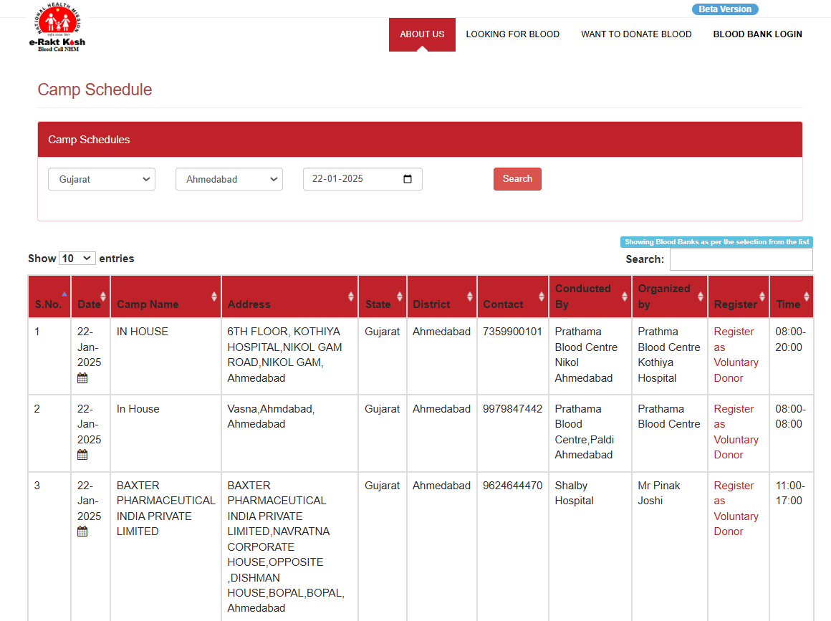

Figure 3.4 Screen-4: Search Donor Availability

**Purpose:** This screen will allow the target end-users to view and search for scheduled blood donation camps in the system. To find a suitable camp, users can filter the information by state, district, and date.

Table 3.4-1 Screen element of Blood Camp Schedule

|  |  |  |  |  |  |
| --- | --- | --- | --- | --- | --- |
| Sr. | Screen Element | Input Type | O/M | 1/N | Description |
| 1 | S.No. | Text | M | 1 | Serial number of the table row. |
| 2 | Date | Date Picker | M | 1 | Date on which the camp is scheduled. |
| 3 | Camp Name | Text | M | N | Name of the blood donation camp. |
| 4 | Address | Text | M | N | Address where the camp is organized. |
| 5 | State | Dropdown | M | 1 | State where the camp is located. |
| 6 | District | Dropdown | M | 1 | District where the camp is located. |
| 7 | Contact | Number | O | 1 | Contact number of the camp organizer. |
| 8 | Conducted By | Text | M | 1 | Organization conducting the camp. |
| 9 | Organized By | Text | M | 1 | Organization managing the event logistics. |
| 10 | Register | Hyperlink | M | N | Link to register as a voluntary donor. |
| 11 | Time | Time Range | M | 1 | Timings during which the camp will operate. |

## 3.5 Screen-5: Camp Registration

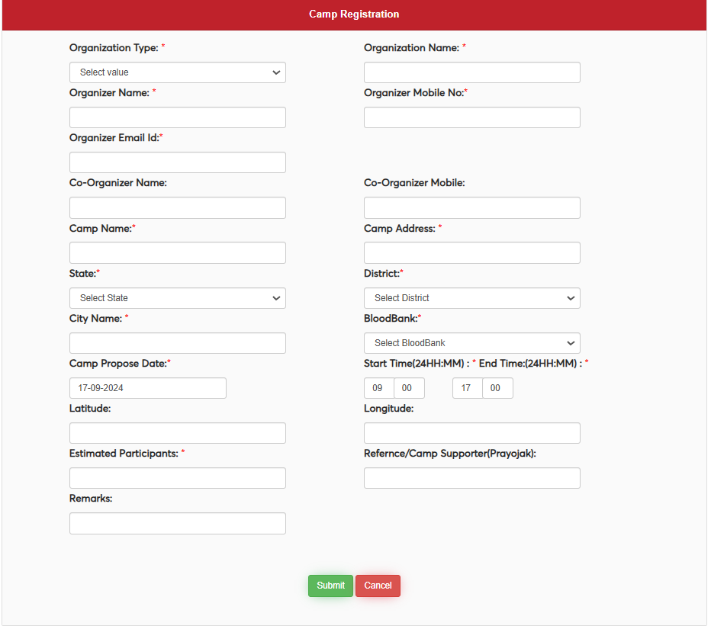

Figure 3.5 screen-5 Blood Camp Registration

**Purpose:** This form will allow the target end-users to register and manage blood donation camps in the system. To register a camp, the following information will be encoded in the system.

Table 3.5-1 Screen Element of Blood Camp

|  |  |  |  |  |  |
| --- | --- | --- | --- | --- | --- |
| Sr. | Screen Element | Input Type | O/M | 1/N | Description |
| 1 | Organization Type | Dropdown | M | 1 | Select the type of the organizing entity. |
| 2 | Organizer Name | Text | M | 1 | Name of the primary organizer of the camp. |
| 3 | Organizer Mobile No. | Number | M | 1 | Contact number of the organizer. |
| 4 | Organizer Email Id | Email | M | 1 | Email address of the organizer. |
| 5 | Co-Organizer Name | Text | O | 1 | Name of the co-organizer of the camp. |
| 6 | Co-Organizer Mobile | Number | O | 1 | Contact number of the co-organizer. |
| 7 | Camp Name | Text | M | 1 | Name assigned to the blood donation camp. |
| 8 | Camp Address | Text | M | 1 | Full address of the camp location. |
| 9 | State | Dropdown | M | 1 | Select the state where the camp is organized. |
| 10 | District | Dropdown | M | 1 | Select the district where the camp is organized. |
| 11 | City Name | Text | M | 1 | Name of the city where the camp is located. |
| 12 | BloodBank | Dropdown | M | 1 | Select the associated blood bank. |
| 13 | Camp Propose Date | Date Picker | M | 1 | Proposed date for the camp. |
| 14 | Start Time (24HH:MM) | Time Picker | M | 1 | Time when the camp starts (24-hour format). |
| 15 | End Time (24HH:MM) | Time Picker | M | 1 | Time when the camp ends (24-hour format). |
| 16 | Latitude | Text | O | 1 | Latitude coordinates of the camp location. |
| 17 | Longitude | Text | O | 1 | Longitude coordinates of the camp location. |
| 18 | Estimated Participants | Number | M | 1 | Approximate number of participants expected at the camp. |
| 19 | Reference/Camp Supporter (Prayojak) | Text | O | 1 | Name of the camp sponsor or supporter. |
| 20 | Remarks | Text Area | O | 1 | Additional comments or remarks about the camp. |
| 21 | Submit Button | Button | M | 1 | Button to submit the form. |
| 22 | Cancel Button | Button | M | 1 | Button to cancel the form submission. |

Figure 3.6-1 Screen-5: Schedule an appointment

## 3.6 Screen – 6 : Donor Feedback

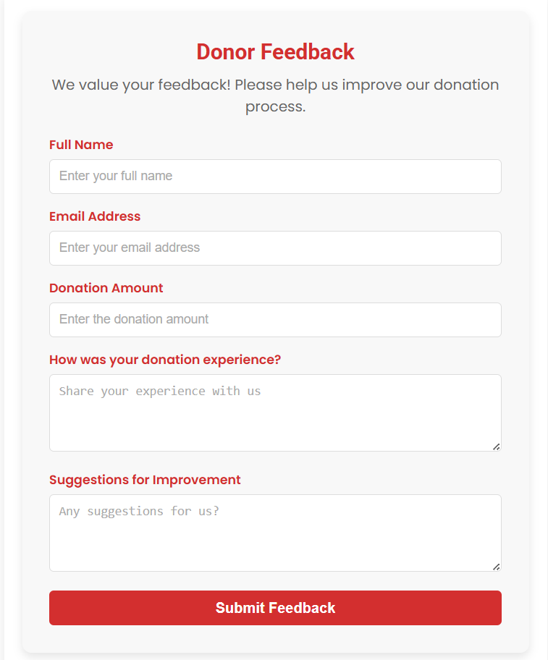

|  |  |  |  |  |  |
| --- | --- | --- | --- | --- | --- |
| sSr. | Screen Element | Input Type | O/M | 1/N | Description |
| 1 | Full Name | Text | M | 1 | The donor's full name. This field is required to identify the person giving feedback. |
| 2 | Email Address | Email | M | 1 | The donor's email address for contacting and following up on their feedback. |
| 3 | Donation Amount | Number | M | 1 | The amount donated by the donor. This helps understand the scale of the donation. |
| 4 | Donation Experience | Textarea | M | 1 | The donor's personal experience while making the donation. |
| 5 | Suggestions for Improvement | Textarea | M | 1 | Feedback or suggestions provided by the donor to improve the donation process. |
| 6 | Submit Button | Button | M | 1 | A button to submit the form after filling in the required fields. |

## 3.7 Screen – 7 : Blood Request Tracking

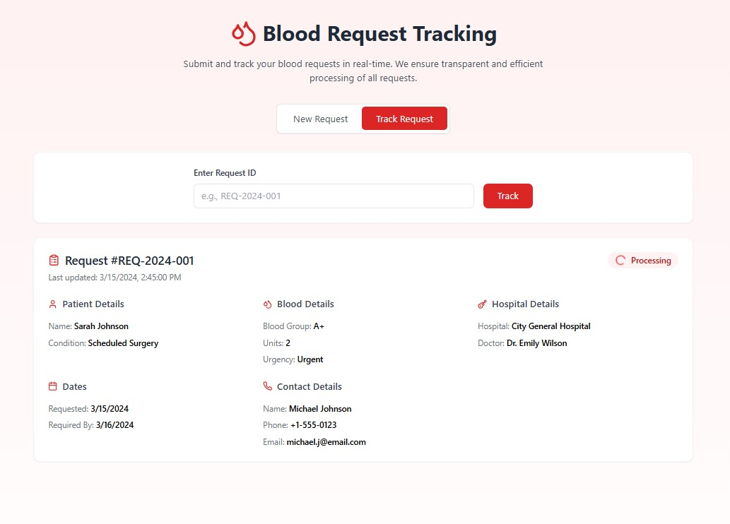

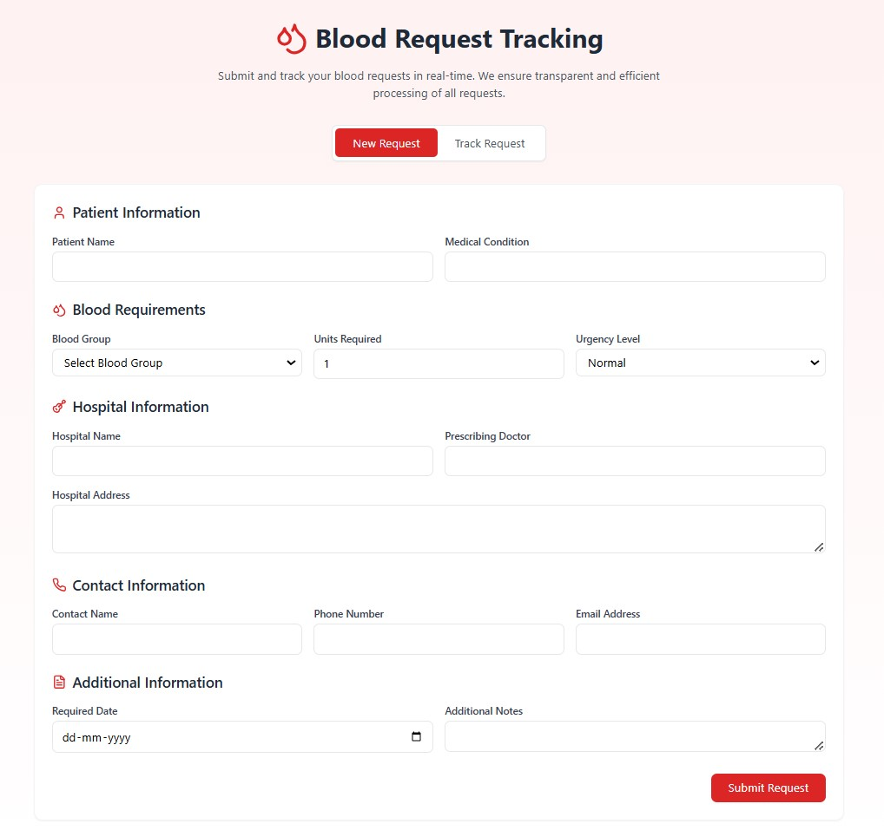

|  |  |  |  |  |  |
| --- | --- | --- | --- | --- | --- |
| Sr. | Screen Element | Input Type | O/M | 1/N | Description |
| 1 | Patient Name | Text | M | 1 | Input field for the patient's name. |
| 2 | Medical Condition | Text | M | 1 | Input field for specifying the patient's medical condition. |
| 3 | Blood Group | Dropdown | M | 1 | Dropdown to select the required blood group. |
| 4 | Units Required | Number | M | 1 | Numeric input to specify the number of blood units needed. |
| 5 | Urgency Level | Dropdown | M | 1 | Dropdown to choose the urgency level (e.g., Normal, Urgent). |
| 6 | Hospital Name | Text | M | 1 | Input field for the hospital's name. |
| 7 | Prescribing Doctor | Text | O | 1 | Input field for the name of the prescribing doctor. |
| 8 | Hospital Address | Textarea | M | 1 | Text area for entering the hospital's address. |
| 9 | Contact Name | Text | M | 1 | Input field for the contact person's name. |
| 10 | Phone Number | Phone Number | M | 1 | Input field for the contact person's phone number. |
| 11 | Email Address | Email | M | 1 | Input field for the contact person's email address. |
| 12 | Required Date | Date Picker | M | 1 | Date picker to specify the required date for the blood. |
| 13 | Additional Notes | Textarea | O | 1 | Text area for adding any additional notes or comments. |
| 14 | New Request Button | Button | M | 1 | Button to navigate to the "New Request" form. |
| 15 | Track Request Button | Button | M | 1 | Button to navigate to the "Track Request" screen. |
| 16 | Request ID | Text | M | 1 | Input field for entering the request ID to track its status. |
| 17 | Track Button | Button | M | 1 | Button to initiate tracking of a request based on the entered request ID. |
| 18 | Request Details Card | Information Card | O | N | Displays detailed information about a specific blood request. |
| 19 | Status Icon (Processing) | Icon | O | 1 | Visual indicator showing the current status of the blood request (e.g., Processing). |

## 3.8 Screen – 8 : Hospital Complaints

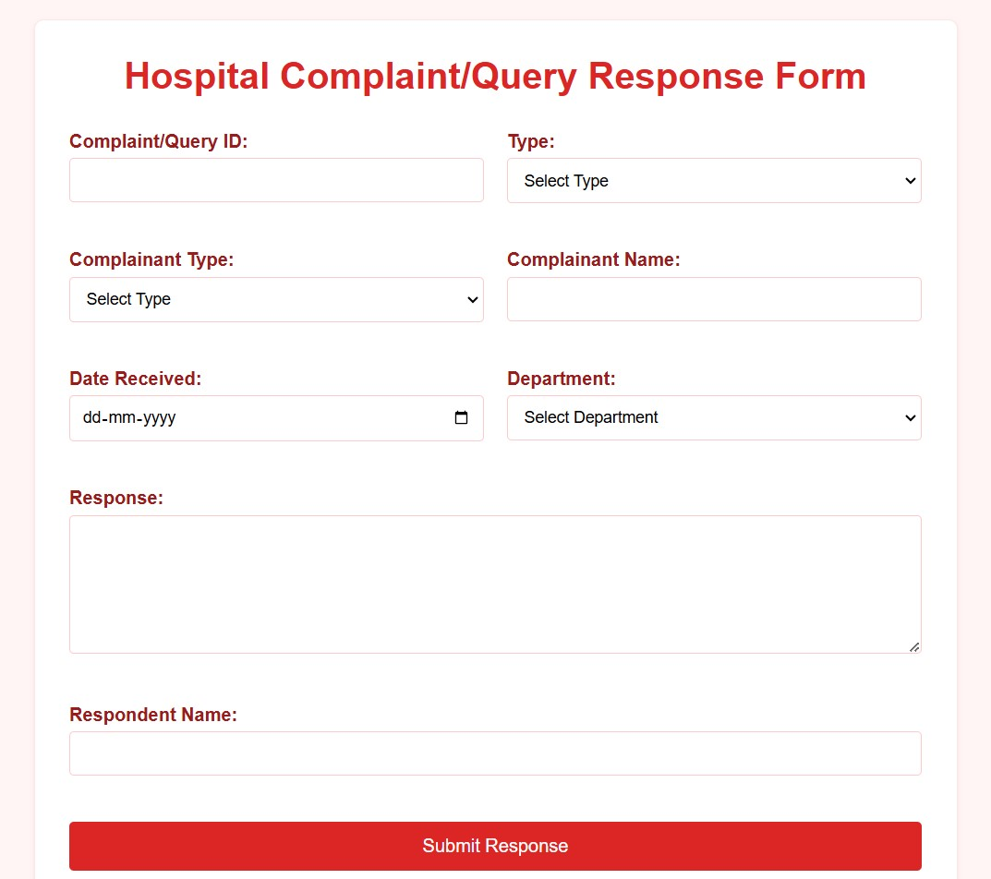

|  |  |  |  |  |  |
| --- | --- | --- | --- | --- | --- |
| Sr. | Screen Element | Input Type | O/M | 1/N | Description |
| 1 | Complaint/Query ID | Text | M | 1 | Input field to enter the unique ID of the complaint or query. |
| 2 | Type | Dropdown | M | 1 | Dropdown to select the type of the query or complaint. |
| 3 | Complainant Type | Dropdown | M | 1 | Dropdown to select the type of complainant (e.g., Patient, Staff). |
| 4 | Complainant Name | Text | M | 1 | Input field for the name of the complainant. |
| 5 | Date Received | Date Picker | M | 1 | Date picker to specify the date the complaint/query was received. |
| 6 | Department | Dropdown | M | 1 | Dropdown to select the relevant department for the complaint or query. |
| 7 | Response | TextArea | M | 1 | Text area to provide a response or resolution to the complaint/query. |
| 8 | Respondent Name | Text | M | 1 | Input field for the name of the person responding to the complaint/query. |
| 9 | Submit Response Button | Button | M | 1 | Button to submit the response form. |

## 3.9 Scre en – 9 : Campaign Report Generation

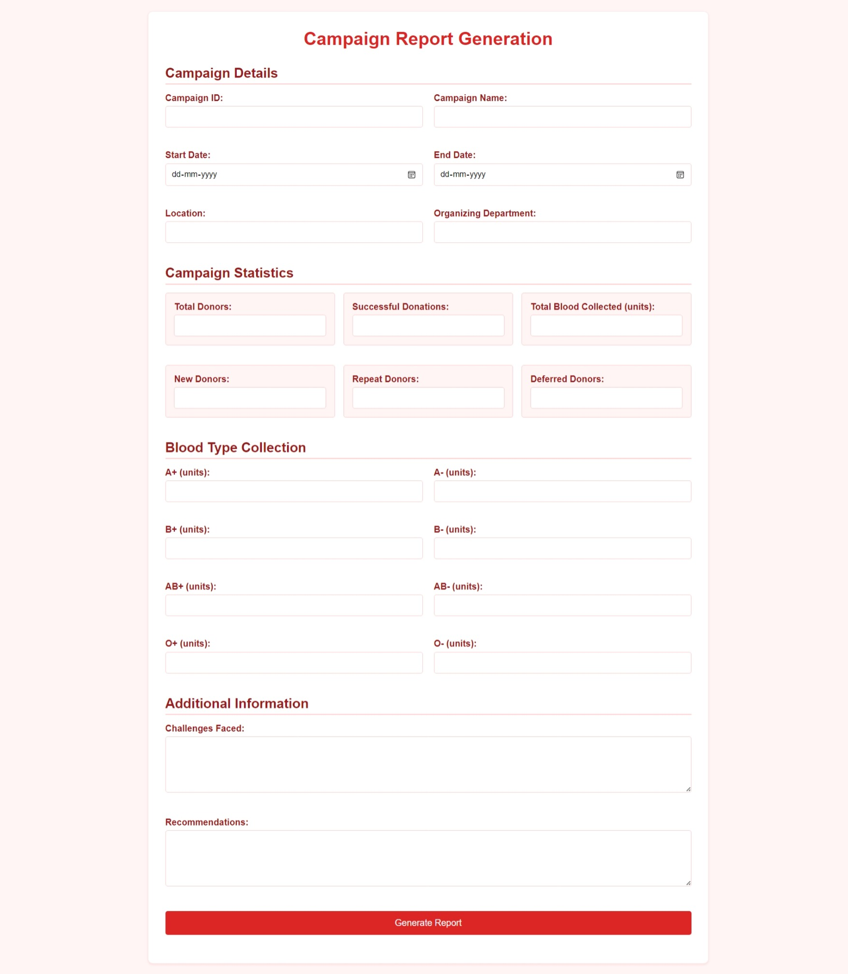

|  |  |  |  |  |  |
| --- | --- | --- | --- | --- | --- |
| Sr. | Screen Element | Input Type | O/M | 1/N | Description |
| 1 | Campaign ID | Text Box | M | 1 | Unique identifier for the campaign |
| 2 | Campaign Name | Text Box | M | 1 | Name of the blood donation campaign |
| 3 | Start Date | Date Picker | M | 1 | Start date of the campaign |
| 4 | End Date | Date Picker | M | 1 | End date of the campaign |
| 5 | Location | Text Box | M | 1 | Location where the campaign is conducted |
| 6 | Organizing Department | Text Box | M | 1 | Department responsible for organizing the campaign |
| 7 | Total Donors | Text Box | O | 1 | Total number of donors who participated |
| 8 | Successful Donations | Text Box | O | 1 | Total successful blood donations |
| 9 | Total Blood Collected | Text Box | O | 1 | Total units of blood collected |
| 10 | New Donors | Text Box | O | 1 | Number of first-time donors |
| 11 | Repeat Donors | Text Box | O | 1 | Number of donors who have donated previously |
| 12 | Deferred Donors | Text Box | O | 1 | Number of donors who were deferred |
| 13 | A+ (units) | Text Box | O | 1 | Units of A+ blood collected |
| 14 | A- (units) | Text Box | O | 1 | Units of A- blood collected |
| 15 | B+ (units) | Text Box | O | 1 | Units of B+ blood collected |
| 16 | B- (units) | Text Box | O | 1 | Units of B- blood collected |
| 17 | AB+ (units) | Text Box | O | 1 | Units of AB+ blood collected |
| 18 | AB- (units) | Text Box | O | 1 | Units of AB- blood collected |
| 19 | O+ (units) | Text Box | O | 1 | Units of O+ blood collected |
| 20 | O- (units) | Text Box | O | 1 | Units of O- blood collected |
| 21 | Challenges Faced | Text Area | O | 1 | Any issues encountered during the campaign |
| 22 | Recommendations | Text Area | O | 1 | Suggestions for future improvement |
| 23 | Generate Report Button | Button | M | 1 | Generates the campaign report |

# Database design

## List of Tables

* Book
* Borrower
* Student
* Staff

Table 4.1‑1 Table: Book

|  |  |  |  |  |
| --- | --- | --- | --- | --- |
| Column | Data Type | Null | Keys & Constrains | Default Value & Description |
| BookID | int | NN | PK (Auto Increment) |  |
| BookName | varchar(100) | NN |  |  |
| ISBN | varchar(100) | AN |  |  |
| Publication_year | int | AN |  |  |
| Language | varchar(50) | AN |  |  |

Table 4.1‑2 Table: Borrower

|  |  |  |  |  |
| --- | --- | --- | --- | --- |
| Column | Data Type | Null | Keys & Constrains | Default Value & Description |
| BorrowerID | int | NN | PK (Auto Increment) |  |
| BookID | varchar(100) | NN | FK | Reference of Book Table |
| BorrowedFromDate | DateTime | AN |  |  |
| BorrowedToDate | DateTime | AN |  |  |
| ActualReturnDate | DateTime | AN |  |  |
| IssuedBy | int | NN | FK | Reference of Student and Staff Table |

Table 4.1‑3 Table: Staff

|  |  |  |  |  |
| --- | --- | --- | --- | --- |
| Column | Data Type | Null | Keys & Constrains | Default Value & Description |
| StaffID | int | NN | PK (Auto Increment) |  |
| StaffName | varchar(100) | AN |  |  |
| IsAdmin | Boolean | AN |  |  |
| Designation | varchar(100) | AN |  |  |

Table 4.1‑4 Table: Student

|  |  |  |  |  |
| --- | --- | --- | --- | --- |
| Column | Data Type | Null | Keys & Constrains | Default Value & Description |
| StudentID | int | NN | PK (Auto Increment) |  |
| StudentName | varchar(100) | AN |  |  |
| Gender | varchar(100) | AN |  |  |
| DOB | DateTime | AN |  |  |
| Department | varchar(100) | AN |  |  |
| Contact | number(10,0) | AN |  |  |

# Stories and Scenario

## Story-1: Add New Book in Library Catalogue

|  |  |  |
| --- | --- | --- |
| *Story # S1* | : | As a Librarian,  I want to add a new book in library catalogue  So that everyone can easily find and borrow it. |
| Priority | **:** | High |
| Estimate | **:** | XL |
| Reason | **:** | The addition of a new book to the library catalogue is crucial for ensuring that the library's collection is up-to-date and accessible to everyone. |

### Scenario# S1.1

|  |  |  |
| --- | --- | --- |
| *Scenario# S1.1* | : | Adding a New Book with Valid Information |
| Prerequisite | **:** | Librarian is logged in to the Library management system. |
| Acceptance Criteria | **:** | **Given:**  The Librarian is navigated to the library catalog management page. Valid book information, including title, author, ISBN, and other relevant details is added.  **When:**  The librarian selects the "Add New Book" option  And The librarian enters valid book details  The librarian clicks the "Save" button to add the book to the catalog.  **Then t**he system successfully adds the book to the catalog and the librarian receives a confirmation message with the book's identification number. |

### Scenario# S1.2

|  |  |  |
| --- | --- | --- |
| *Scenario# S1.2* | : | Adding a New Book with Invalid Information. |
| Prerequisite | **:** | The librarian is logged into the library management system. |
| Acceptance Criteria | **:** | **Given:** The librarian is on the library catalogue management page  **When:** The librarian selects the "Add New Book" option and the librarian enters an incomplete or incorrect book details and librarian clicks the "Save" button to add the book to the catalogue.  **Then t**he system displays error messages for the incorrect or missing information and the book is not added to the catalogue. |

### Scenario# S1.3

|  |  |  |
| --- | --- | --- |
| *Scenario# S1.3* | : | Attempting to Add a Duplicate Book |
| Prerequisite | **:** | The librarian is logged into the library management system and the librarian is on the library catalogue management page |
| Acceptance Criteria | **:** | **Given**: The book information, including title, author, ISBN, and other relevant details, is available and the book with the same ISBN is already in the catalogue.  **When**: User Clicks on “Add book” button. Enter a number of copies with the same book detail mentioned in the field.  **Then**: Generate unique book id, barcode and spine label for various book of same title. |

## Story-2: Search Book

|  |  |  |
| --- | --- | --- |
| *Story # S2* | : | As a Librarian or member,  I want to search for books by title, author, or keyword,  So that I can quickly find books that match my interests. |
| Priority | **:** | High |
| Estimate | **:** | M |
| Reason | **:** | Implementing a search functionality is essential for enhancing the user experience, as it allows librarian and member to efficiently discover and access the library's resources. |

## Story-3: Manage due date for borrowed book

|  |  |  |
| --- | --- | --- |
| *Story # S3* | : | As Librarian,  I want to manage due dates for borrowed books  So that I can ensure that books are returned on time and avoid overdue fines. |
| Priority | **:** | High |
| Estimate | **:** | M |
| Reason | **:** | Proper due date management is crucial for maintaining the library's collection and ensuring that books are available for all members. |

## Story-4: Renew book

|  |  |  |
| --- | --- | --- |
| *Story # S3* | : | As Librarian,  I want to renew a book that I have borrowed  So that I can extend my borrowing period if needed. |
| Priority | **:** | Medium |
| Estimate | **:** | M |
| Reason | **:** | Book renewal functionality is a convenience feature for librarian, allowing them to keep a book for an extended period if no one else has requested it. |

## Story-5: Generate a report on book usage and availability

|  |  |  |
| --- | --- | --- |
| *Story # S3* | : | As Librarian,  I want to generate reports on library usage and book availability  So that I can make informed decisions about library’s books. |
| Priority | **:** | Medium |
| Estimate | **:** | L |
| Reason | **:** | Reporting functionality helps librarians track the usage of library resources and make data-driven decisions to improve services and collections. |

# Test cases

|  |  |  |  |
| --- | --- | --- | --- |
| Project Name: | EMI Calculator | Test Designed by: | P. U. Jadeja |
| Module Name: | **Login** | **Test Designed date:** | 01-10-2023 |
| Release Version: | **1.0** | **Test Executed by:** | **R. B. Gondaliya** |
|  |  | **Test Execution date:** | 15-01-2023 |

|  |  |  |  |  |
| --- | --- | --- | --- | --- |
| Pre-condition: Web application should be accessible | | | | |
| Test Case ID | **Test Title** | **Test Type** | **Description** | **Test Case ID** |
| TC_001 | Login to web application with valid credential | Functional | Login to Library management system web application through valid credential | TC_001 |
| TC_002 | Login to web application with invalid credential | Functional | Login to Library management system web application through invalid credential | TC_002 |
| TC_003 | Varify login page elements | GUI | varify that all elements are availabe on login page | TC_003 |

|  |  |
| --- | --- |
| **Test Case Title** | Login to web application with valid credential |
| **Test Type** | Functional |
| **Test Priority** | High |
| **Pre-condition** | Web application should be accessible |

|  |  |  |  |  |  |  |  |
| --- | --- | --- | --- | --- | --- | --- | --- |
| **Test Step** | **Test Case Description** | **Expected Result** | **Actual Result** | **Status** | **Comment** | **Data** | **BUG ID** |
| 1 | Access Web application URL | The site launched properly | Site launched successfully | Pass |  | <https://accounts.google.com/ServiceLogin> |  |
| 2 | Enter valid Username in username field | Username field should be editable and accept the Username | Username input accepted | Pass |  | Username:  Rbgondaliya@gmail.com |  |
| 3 | Enter valid Password in Password field | Password field should be editable and accept the password and display as star or dot | Password input displayed in dot and accepted | pass |  | Password: rbgondaliya |  |
| 4 | Enter valid captcha code in captch field | Captch field should editable and accept captcha and captcha is case sensitive | Captcha input accepted | Pass | Step required when human action validation perform | get captcha from image which is near by captcha field |  |
| 5 | Click on login button | User should login into site and navigated to dashboard | User navigated to dashboard and username should br display in top of the right side. | pass |  |  |  |

|  |  |
| --- | --- |
| **Test Case Title** | Login to web application with invalid credential |
| **Test Type** | Functional |
| **Test Priority** | Medium |
| **Pre-condition** | Web application should be accessible |

|  |  |  |  |  |  |  |  |
| --- | --- | --- | --- | --- | --- | --- | --- |
| **Test Step** | **Test Case Description** | **Expected Result** | **Actual Result** | **Status** | **Comment** | **Data** | **Bug ID** |
| 1 | Verify that User is not able to Login with invalid Username and invalid Password | Should be display an error message enter wrong username or password | Display an error of wrong username and password | Pass |  |  |  |
| 2 | Verify that User is not able to Login with Valid Username and invalid Password | Should be display an error message enter wrong password | Display an error of wrong password | Pass |  |  |  |
| 3 | Verify that User is not able to Login with invalid Username and Valid Password | Should be display an error message User not found | Display an error Username not found | Pass |  |  |  |
| 4 | Verify that User is not able to Login with blank Username or Password | Set required field validation message for Username and Password | Display an error of wrong username and password | Fail | Not performa a validation function fix it |  | Bug_002 |

|  |  |
| --- | --- |
| **Test Case Title** | Varify login page elements |
| **Test Type** | GUI |
| **Test Priority** | Medium |
| **Pre-condition** | Web application should be accessible |

|  |  |  |  |  |  |  |  |
| --- | --- | --- | --- | --- | --- | --- | --- |
| **Test Step** | **Test Case Description** | **Expected Result** | **Actual Result** | **Status** | **Comment** | **Data** | **Bug ID** |
| 1 | Launch application with the given url | The site launched properly | Site launched successfully | Pass |  | <https://accounts.google.com/ServiceLogin> |  |
| 2 | Verify that the login screen contains elements such as Username, Password, Sign in button, Remember password check box, Forgot password link, and Create an account link. | All listed control displayed properly on the page | Login page loaded successfully | Pass |  |  |  |
| 3 | Verify that cursor is focused on “Username” text box on the page load | Cursor is focused in Username textbox | Cursor focus in Username textbox | Pass |  |  |  |
| 4 | Verify that tab functionality is working properly or not | When tab pressed cursor move in next control | Cursor moving in next control | Pass |  |  |  |
| 5 | Verify that all the fields such as Username, Password has a valid placeholder | All text fields have proper placeholder | All text fields have proper placeholder | Pass |  |  |  |
| 6 | Verify that the labels float upward when the text field is in focus or filled (In case of floating label) | When field is focused or filled, label display on top of the filled | When field is focus or filled, label display on top of the filled | Pass | step required when fields with floating label |  |  |
| 7 | verify that forgot password link working properly | when click on forgot password load forgot passworg page | forgot password link not working | Fail |  |  |  |

# References

* http://www.w3schools.com/html/html_intro.asp
* https://www.w3schools.com/php/default.asp
* https://www.javatpoint.com/uml